Monday, 6 December 2021

Preparing your student’s iPad for School.
Dear Parents and Carers,
This year, Corinda State School will use Intune mobile device management to access required Apps for new BYO devices. This replaces iTunes U, which is no longer supported by Apple.
Under this model, you will follow simple instructions to enrol in Intune and download all required free apps. It will also set the iPad up so that your student can log onto the school network straight away, on the first day of school.
In January 2002, you will receive a once only invoice for $20. This will cover the cost of the required paid Apps (3 apps) for your student, while they remain at Corinda State School. Once paid, these Apps will be made available to your student, by the school (usually within 72 hours).
How to Get Started
- Start by setting up your new iPad according to Apple instructions.
- Make sure the first sign in is with the Apple ID of a Parent or Guardian (not the child).
- Follow initial set up Instructions from Apple
- Set up an Apple ID for your child using the following instructions.
Creating a separate Apple ID for your child means that you have control over what is downloaded and if your child forgets the device passcode, you can help reset it.
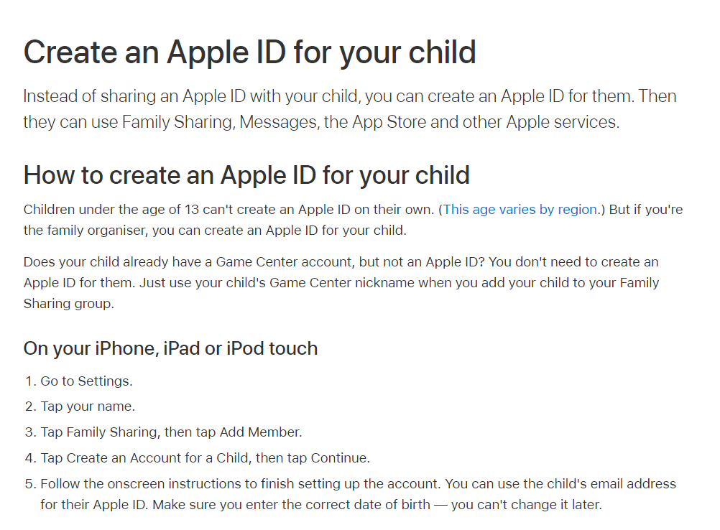
Follow these instructions from Apple Support.
https://support.apple.com/en-au/HT201084
Next Open the App store and download the Intune Company Portal App.
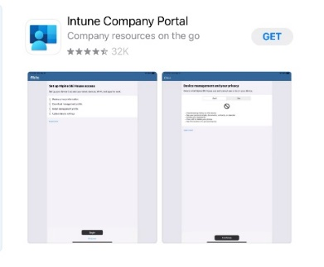
- Once downloaded follow the instructions on this video to install.
https://mediasite.eq.edu.au/mediasite/Play/bbe46710d2c24274a0a99cba446a92031d
We recommended you watch on another device, stopping as you need.
We recommend you change temporarily change you iPad settings to avoid your iPad turning off during this process.
Got to Settings, select Display, select Auto-lock, select Never
You will need your child’s school email address, username and password.
These details have been provided in hard copy to each student
School Email address:
School username:
School password:

Step by step written instructions and these links are available under the e-learning tab on our school website, should you prefer.
This process may take up to 30 minutes and uninterrupted internet connection is required for this time.
If you get a bit lost or have any difficulties, we are able to help you. From Wednesday 19 January 2022, you can contact Kirsty Prior on kprio14@eq.edu.au if you have any issues or problems.

We are excited to welcome this new cohort to our BYOD program and please know we are here to support you in this transition.

Regards
Michelle Madden- Hallet
A/Deputy Principal

